'Around the World Calendar on History, Customs, Festivals and Celebrations”
POLAND
DATE | NAME | DESCRIPTION | EVIDENCE
1 st of January | New Year’s Day | While most of the celebrations start on the evening of the 31st of December, it’s New Year’s Day, falling on the 1st of January as per Gregorian tradition, that’s officially declared a National holiday, as most people will have sleepless nights. Expect shopping centres and most of the shops to be closed. | 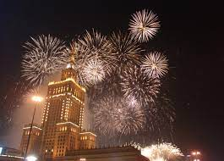
6th of January | The Epiphany | Most Poles recognise this holiday (also known as the “Three Kings’ Day”) by writing in chalk over their front doors, the year plus the initials of the three monarchs that followed the star (so for instance 2023 K+M+B, after Kacper, Melchior and Baltzar – the Polish names for Casper, Melchior and Balthasar). | 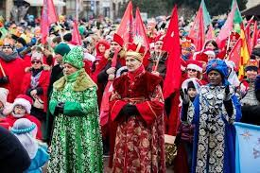
A moveable feast, which  takes place between  22nd of March and 25th  of April | Easter | Easter, alongside Christmas, are the most important holidays in Poland, not only for Polish Christians. Please take this into account when making your order for goods or arranging meetings or visits. Traditionally, Polish families prepare for Easter, by preparing special dishes associated with this holiday. On Good Friday, Poles fast in preparation for Easter and the most popular food on this day are herrings served in many different ways. On Easter Saturday a basket of food, which is to be eaten on the special Sunday breakfast, is taken to the church to be blessed. The most important item in the basket are painted eggs called pisanki. They are hand-painted and can be richly ornamented. Śmigus Dyngus, known as Wet Monday, follows Easter Sunday and is a day off work for most businesses. | 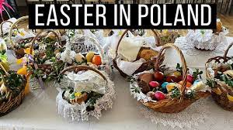
1 st of May | Labour Day | This holiday, instituted to commemorate the brutal repression of workers in Chicago at the end of the 19th Century, has a relatively short history in Poland, officially dating back to the 1950s when the Polish Communist Government declared it a State holiday. | 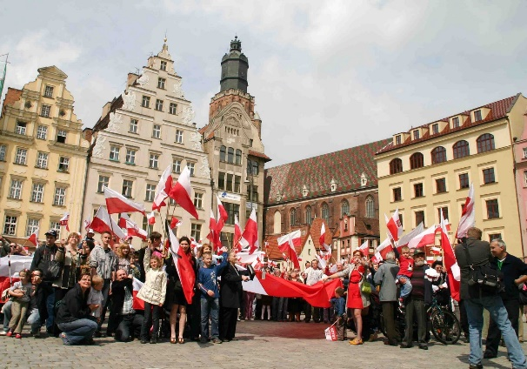
3rd of May | Constitution Day | The 3rd of May is a very important holiday for the modern Polish state, as it marks the date of the official proclamation of the Polish Constitution – the second oldest one in the world and the oldest one in Europe. It was acclaimed in 1792, shortly before the final partitinoing of Poland. | 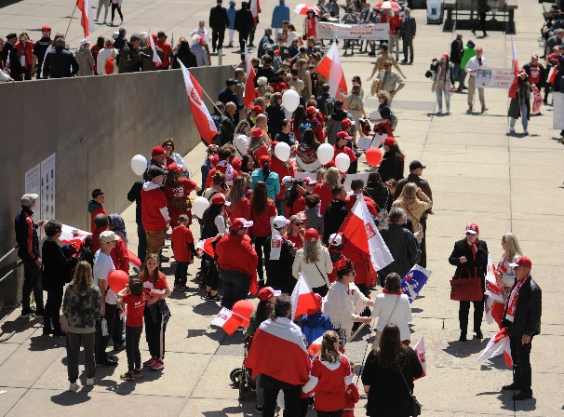
the Sunday, 7 weeks after Easter | Pentecost | Penecost is a significant liturgical event, commemorating the descent of the Holy Spirit upon the Apostles. As this holiday always falls on a Sunday, it is already a day off for most businesses, so its economic impact is fairly limited. Expect regular working hours in the days leading up to and after the holiday. | 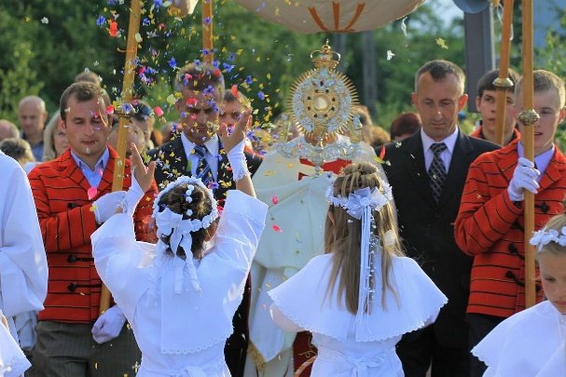
11 days after Pentecost | Corpus Christi | Corpus Christi follows 11 days after Pentecost, falling always on a Thursday. While most restaurants and cafes remain open on that day, supermarkets and other larger shops are not. Visitors to Poland can be surprised by large religious processions taking place on that day. | 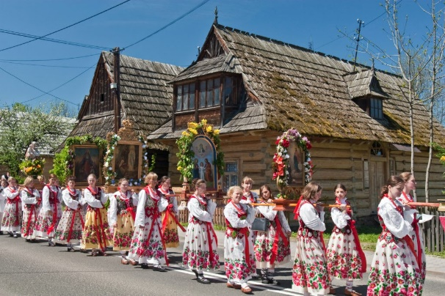
15th of August | Assumption of the blessed Mary / Armed Forces Day | This joint religious and State holiday happens to commemorate two important events – the Assumption of Mary, mother of Jesus, and the Armed Forces Day, instated after the victory of the Polish armed forces over the Soviet army in 1920.This victory is often called Cud nad Wisłą – the miracle on the Wisła river. As this victory was a real miracle. This is a Nationwide celebration, with military parades happening across the country, while many Polish Catholics make a pilgrimage to Częstochowa where the Holy Image of Our Lady of Częstochowa is to be found. | 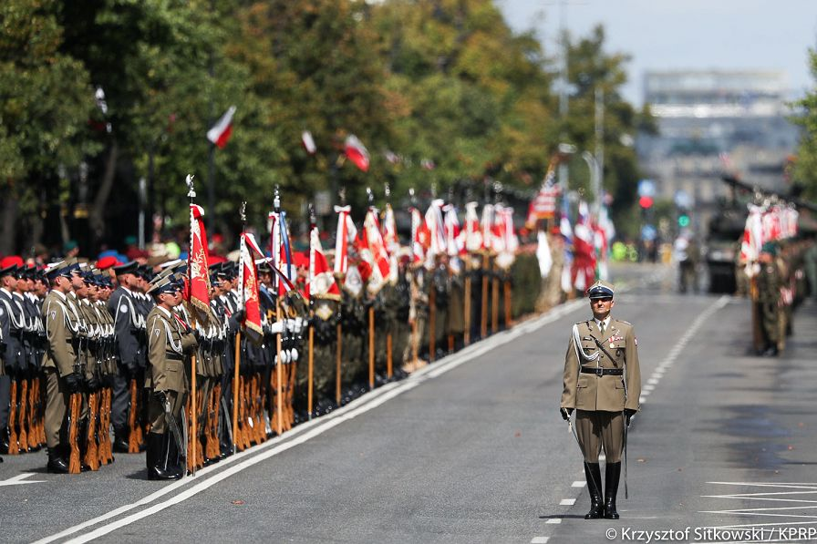
1st of November | All Saints’ Day | All Saints’ Day is a sombre day when nearly all Poles travel to the places where their beloved deceased are buried. Shops remain closed for the day, and most cafes and restaurants operate on different schedules. | 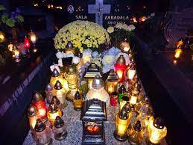
11th of November | Independence Day | On 11th of November 1918 Poland declared independence after 123 years of foreign oppression and partitioning. This date commemorates the rebirth of the Polish state, and as such, it is celebrated by Poles, as above all we value our freedom and independence. This day is also celebrated on a Governmental level as well as by various political and non-political groups. Patriotic marches are to be expected, especially in larger cities. | 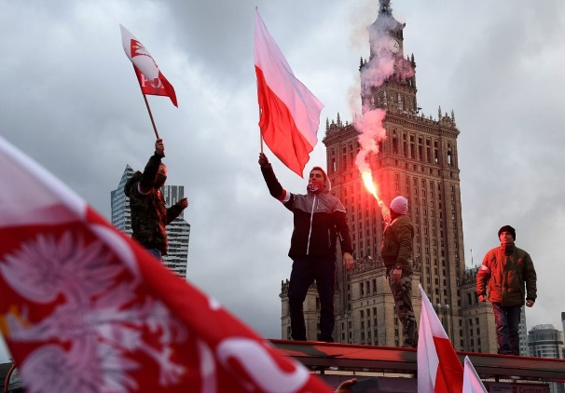
25th of December | Christmas Day | This widely celebrated Christian holiday is one of the major festivals in Polish calendar and occupies an important role in both Polish culture and the economy. This also tends to be a period for larger family gatherings, with people often travelling to their hometowns a couple days ahead of Christmas to meet up with their loved ones. | 