ROMANIA

DATE | NAME | DESCRIPTION | EVIDENCE
The 24th of January | The Day of the Union-The Small Union | The event that took place on this specific date, the 24th of January 1859, is known as the Small Union, which represents the election of Alexandru Ioan Cuza as the sole leader of Moldavia and Wallachia and thus, the unification of the two. It was the first step that took our ancestors closer to fulfilling their desire of uniting the three principalities, Wallachia, Moldavia and Transylvania, therefore this day carries a big significance for us, Romanians and it is celebrated every year | 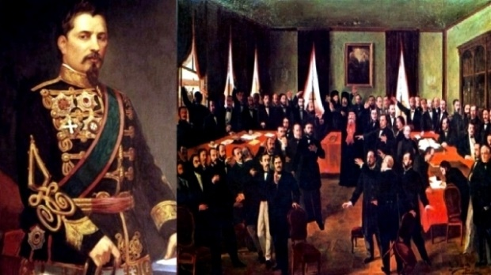  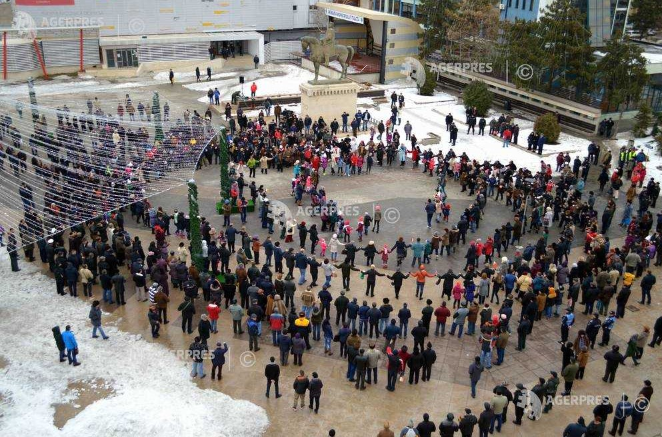
The 10 th of May | The Independence Day  The Kings‘ Day or the Monarchy‘s Day | On the 9th of May 1877, Romania declared its independence from the Ottoman Empire and on the 10th of May the Proclamation of Independence id signed by Carol, the ruler of the country. However, this was not officially recognised, so on the same day, the Romanians went to war alongside Russia against the Ottoman Empire to win its independence from the Ottoman Empire  On 10th of May 1881, King Carol I was crowned. Before this event, the constitution from 1866 was amended in order to specify, among other things, that Romania, from there on, shall be named The Kingdom of Romania, whilst its ruler shall be given the title of king | 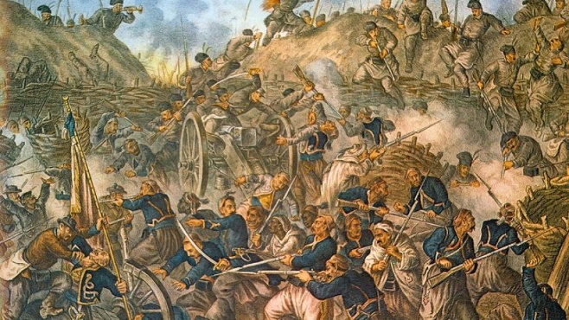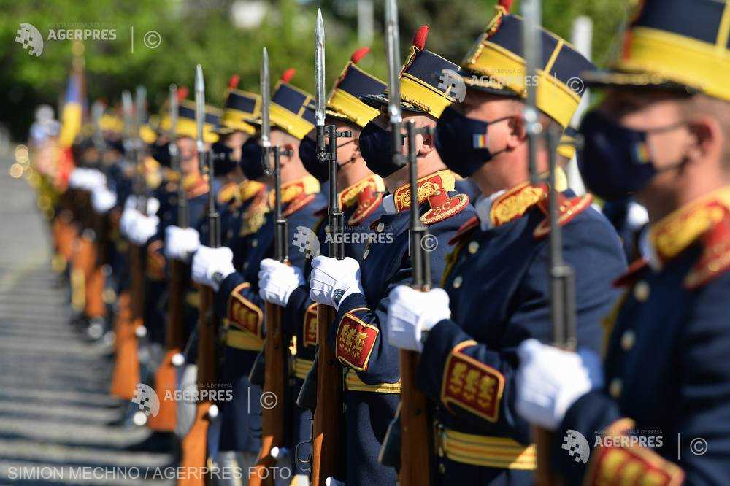  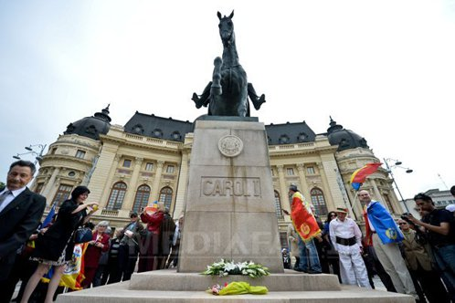
The 1st of December | The Great Union  Romania‘s national Day | On the 1st of December 1918, the Great Union took place, when all the historic provinces inhabited by Romanians (The Kingdom of Romania, Bukovina, Bassarabia and, eventuallly, Transylvania) were united at last into one country with the name of Romania (Great Romania). | 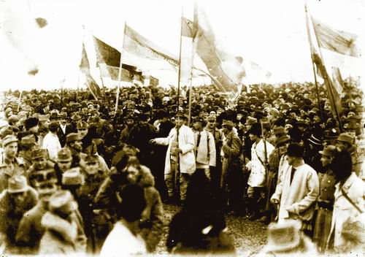  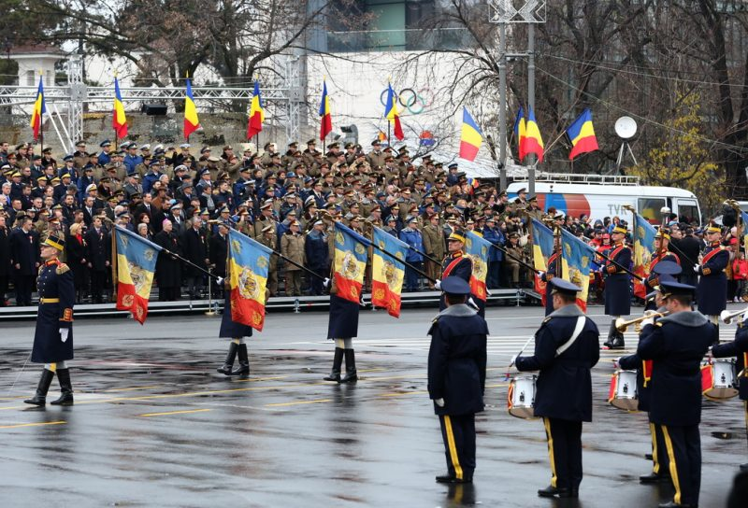
The 22nd of December | The Victory of the Revolution‘s Day | During the communism , the Romanians led a hard life. Essential human rights and needs were violated. Ceausescu, perhaps the most notorious personality, came to power in 1965. After having endured over 20 years of unjustice and sufference, the Romanians started the Revolution in Timisoara on the 16th of December 1989 and this fight spread rapidly around the country. On the 22nd of December 1989, Ceausescu fled from the capital and was captured in Târgoviște where he stood trial, along with his wife. They were found guilty and sentenced to death on Christmas Day.a | 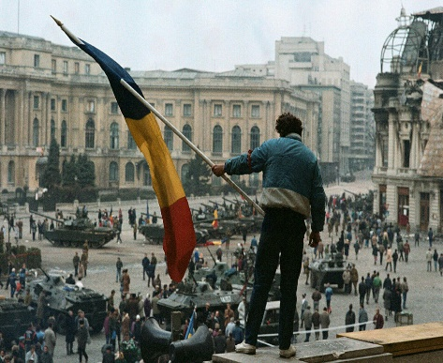  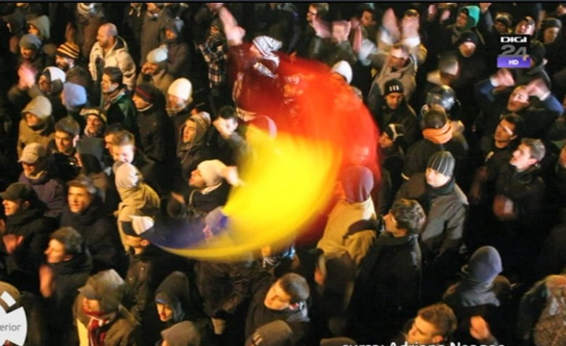
The 1st of March | The March Trinket‘s Day | The 1st of March means the beginning of the spring season, but for the Romanians it is closely related to the tradition of offering March trinkets, an ancient symbol that celebrates the changing of seasons and the rebirth of nature.  The March trinket is made of two twisted wool or silk threads, one white and one red, to which a craft object is attached, to be given to ladies and young ladies on the first day of spring. They will wear it hanging on their chest for one or more days. It is said that the March trinkets are carriers of luck and happiness, that's why other symbols of luck, such as four-leaf clovers, a horseshoe or a heart are added to this string which is tied in the form of a bow. | 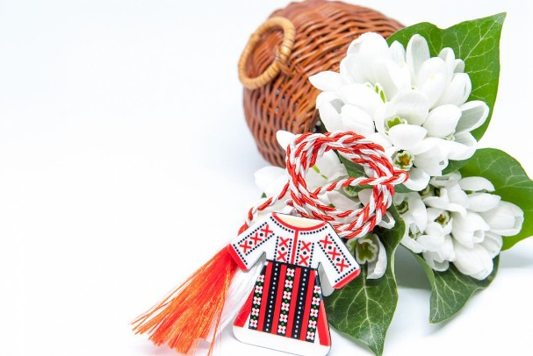
The 1st of June | The Child‘s Day | The 1st of June represents the Child's Day, the day when all children feel good, receive gifts, have fun together. The Child's Day means joy for children, colourful balloons, toys, sweets, new clothes, games and amusements in parks, new friends, generosity, love, innocence, purity, tenderness, painting, dances, walks, drawings on the asphalt, movies, wishes, congratulations. On this day, each of us remembers the beautiful moments of childhood, thinking back to the past or reliving it through the child’s eyes. | 