TURKEY

DATE | NAME | DESCRIPTION | EVIDENCE
29 OCTOBER | Republic Day | The Republic of Turkey was established by Atatürk and his friends at 29 October 1923. On October 29,the anniversary of establishing of the republic is celebrated with great enthusiasm throughout the country with various events. | 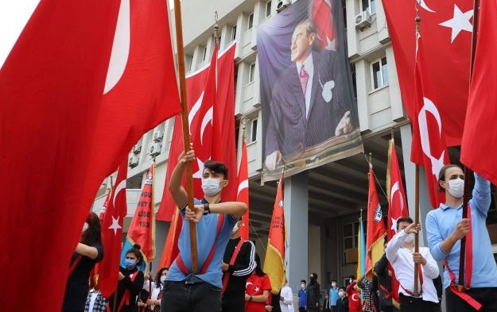

TURKEY

DATE | NAME | DESCRIPTION | EVIDENCE
23 APRIL | National Sovereignty and Children‘s Day | The opening date of the Grand National Assembly of Turkey is, 23 April 1920. It was given as a holiday to the children of the world by the great leader Mustafa Kemal ATATÜRK. April 23 is celebrated every year as a festival withchildrens we host from many countries. | 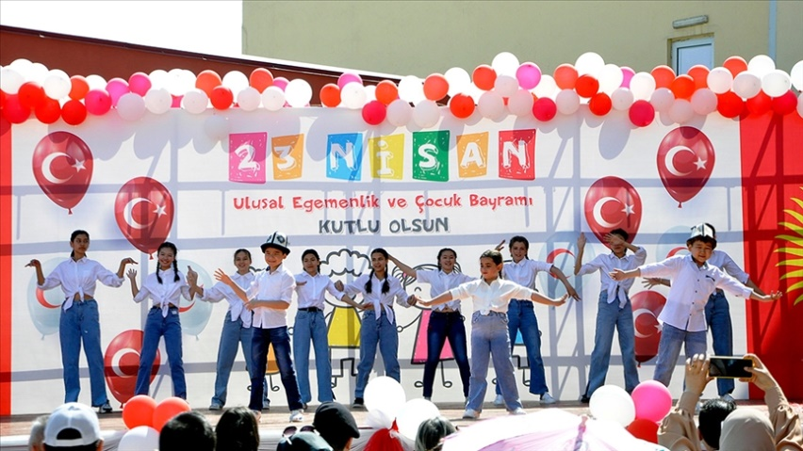

TURKEY

DATE | NAME | DESCRIPTION | EVIDENCE
19 MAY | Youth and Sports Day | Turkis people startedv their struggle for freedom at 19 May 1919. 19 May is celebrated as a youth and sports festival all over Turkey . | 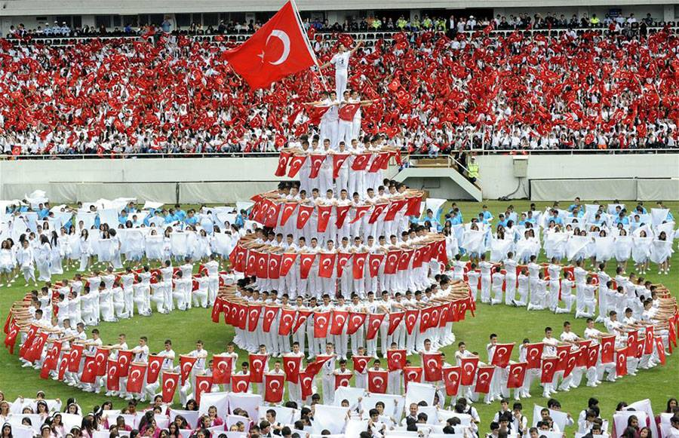

TURKEY

DATE | NAME | DESCRIPTION | EVIDENCE
10 NOVOMBER | Commemoration Day of the ATATÜRK. | The Turkish great Atatürk died at 10 November 1938. On November 10, we commemorate Atatürk throughout the Turkey with respect and gratitude. | 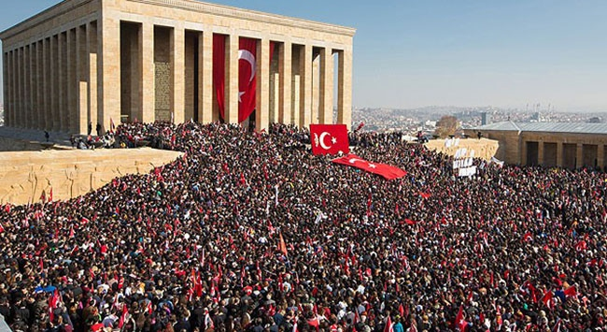

TURKEY

DATE | NAME | DESCRIPTION | EVIDENCE
End of the Ramadan Month | Ramadan Holiday (Religious Holidays) | Ramadan or sugar holiday marks end of the obligatory fast during the month of Ramadan

TURKEY

DATE | NAME | DESCRIPTION | EVIDENCE
Two Months Later from Ramadan Holiday | Eid al-Adha (Religious Feast) | It expresses the individual‘s ability to sacrifise everything for God and being grateful to God. | 