ERASMUS+ 2020-1-PL01-KA229-081615
Name of the school:
Logo :

'Let’s protect our landscapes with a environmentally-friendly attitude to what heritage tourism means'
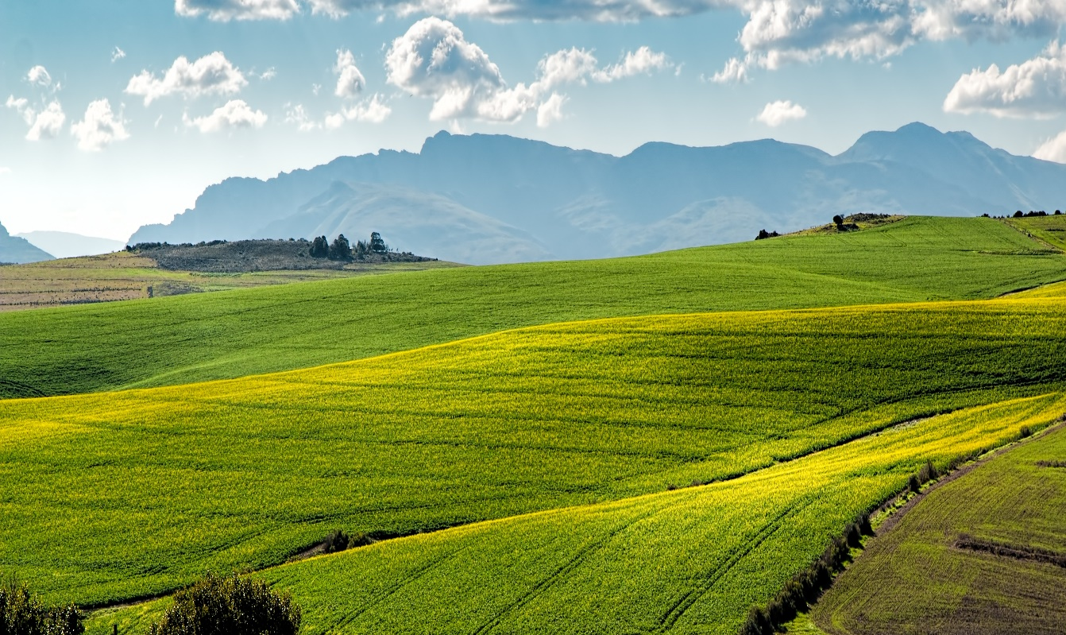
COLEGIUL NATIONAL ‘ION LUCA CARAGIALE’ MORENI, ROMANIA

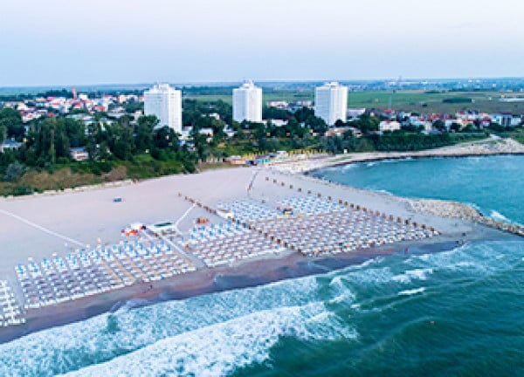  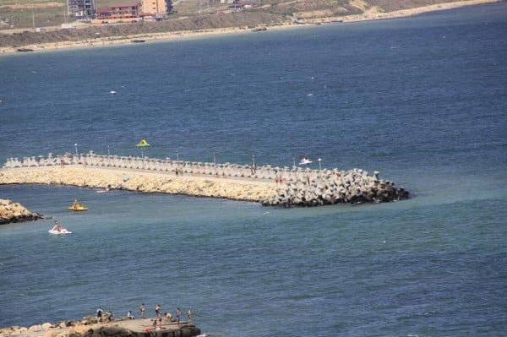 | The Romanian coastline is part of the western shore of the Black Sea and stretches from the border with Ukraine to the border with Bulgaria.  The Romanian coast stretches over several resorts, which gives us a wide variety in choosing where to go to the sea. For example, if you want to have some good fun, you can opt for Costinești or Vama Veche, because teenagers generally go there and spend most of their time hanging out. If you want to have a much quieter and more relaxing vacation, you can opt for Saturn or Jupiter, because the atmosphere is quieter, and the tourists are mostly families. However, the other resorts vary between these two types of resorts, because the others do not have this nightlife present, but the excitement is at a high level, so standing in endless queues is not missing.  Also, it is one of the most visited areas in our country, so it is often polluted by those who go to the sea in the summer season. there are many people who choose to leave their waste on the beach, instead of having a container to put it in, so the beach is often dirty.
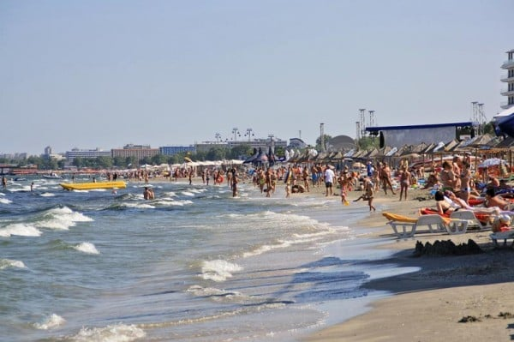  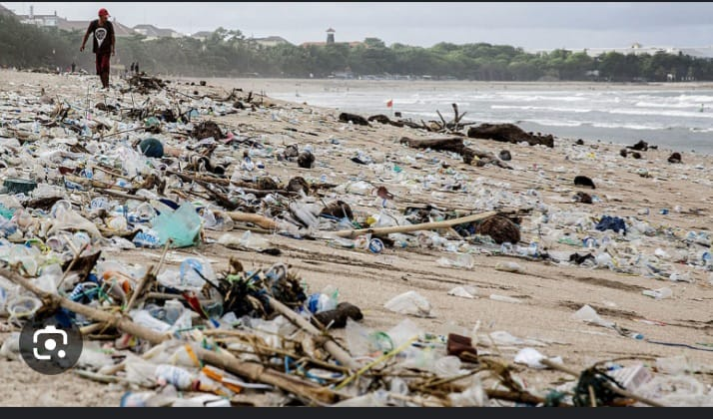 | To protect the beaches:  - we can join certain volunteer clubs for waste collection  - we can put more trash cans on the beach  - we can warn people about throwing waste, and they will be more careful - we can have a small bag with us, in which to put the packaging and leftovers  - we can put some posters on the beach highlighting the consequences of throwing waste on the beach  Considering the fact that the number of tourists has grown considerably over the years, each mayor of each resort decided to enlarge the beaches, so that the tourists stay much more comfortable and relaxed. In addition, they have installed many more trash cans, so as to avoid throwing waste on the sand, but in vain, because people continue to choose the easier way, throwing them anywhere, but we hope that in the future our population will recover and that the consequences will be too severe.

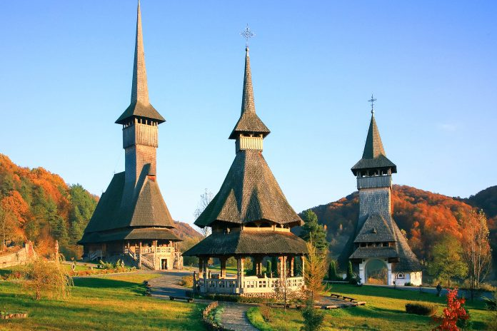  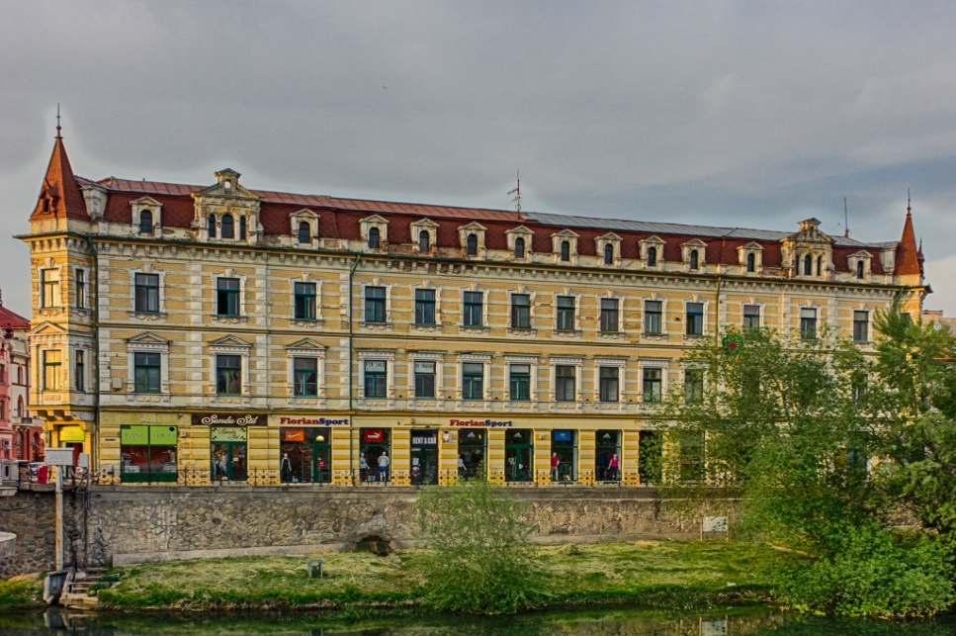 | Romanian architecture is very diverse, including medieval, pre-World War I, postwar, and contemporary 21st century architecture. In Romania, there are also regional differences with regard to architectural styles. From the middle ages to the early 20th century, in Romania there were two types of construction with both different materials and techniques.  The first is peasant architecture, whose most spectacular achievements were the wooden churches, especially those in the villages of Maramures, Banat where the tradition is still carried out today. The second consists mainly of monasteries, as well as princely seats or boyar mansions. Most of the old lay edifices were destroyed by time, wars, earthquakes and fires.  In medieval architecture, influences of Western trends can be traced, to a greater or lesser extent, in all the three lands inhabited by Romanians. Such influences are stronger in Transylvania, and weaker in Moldavia, in forms absorbed by local and Byzantine tradition. In Wallachia, Western elements in architecture were even fewer; there, from the 14th-century architecture was based on the local adaptation of the Byzantine model (the Princely Church in Curtea de Arges and the Cozia Monastery). In the first half of the 19th century, urban life grew considerably and there was a Western-oriented modernization policy. During this century, the predominant style was Classicism which lasted for a long time, until the 20th century, although it coexisted in some short periods with other styles.
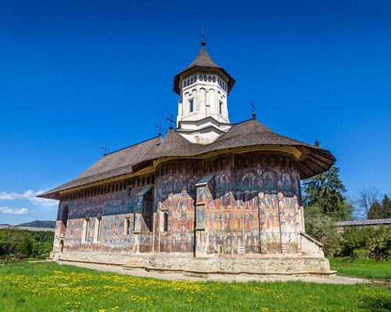  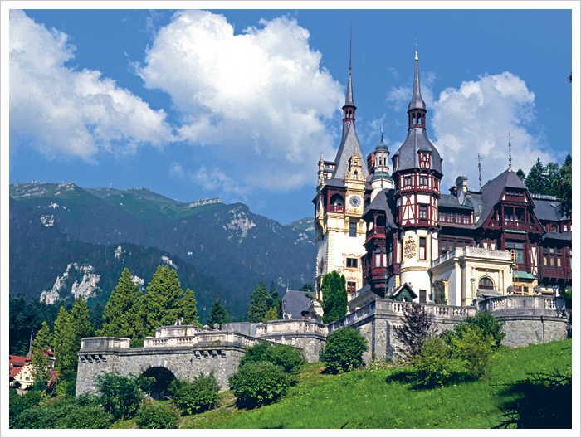 | Architecture is a very important landmark for Romania. Since a lot of historical buildings have been destroyed in earthquakes or during communism, new rules have been implemented. There is a national register of historical monuments, establishing a system of protected areas around these buildings, and taxes are implemented in order to preserve and to restore architecture.  There are also strict regulations around the use and development of historical buildings. Any changes made to a historical building must be approved by a government agency, and new construction in the vicinity of these buildings is often subject to strict zoning laws.  The public is also very educated about the importance of preserving historical buildings, through the public awareness campaigns and educational programs in schools and universities. Strict policies and regulations are also enforced by law.

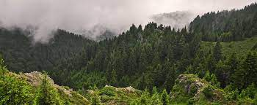  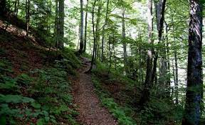  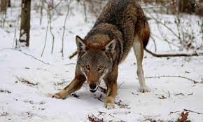 | Romania covers 24 million hectares of which 6.9 million are covered by forests: 11% of forests are aged between 1 and 20 years;  71% are aged between 20 and 100 years;  17% are over 100 years old;  0.8% have been around for more than 160 years;  as stated in a study by IFN in 2016.  Simply put, Romania holds 2.3 billion metric cubes of wood  Two thousand years ago Romania held 15-17 million hectares of forest. Throughout history Romanians have built cities in the forests so that they could defend themselves from invaders. The city walls were made out of thick wood which can be observed in cities such as Bucharest, Sibiu and Brasov.  Before the 16th century cutting wood was an arduous task and as such deforestation wasn’t an issue, but with the introduction of the woodcutting machine the forests dwindled to only 8.5 million hectares.  In 1918 after the arrival of locomotives and because of the growing need for crops the forests reached 7.2 million hectares. The lowest point of the Romanian forests was reached in 1938 when they only covered 5.9 million hectares.  The red wolf (Canis rufus) is the rarest species of wolf only found in Romania and America. In Romania most of these wolves have been killed by excessive hunting, but they have survived only through mixing with a different species.

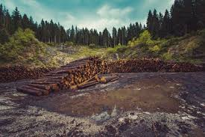  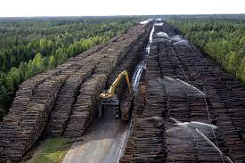 | Romania holds 2.3 billion metric cubes of wood, with that in mind the IFN has stated that wood must be taken from the forests at a rate of 21 million metric cubes per year so that our forests may maintain their numbers. Sadly, this law is not respected and Romanian trees are being cut down at a rate of 38 million metric cubes per year. Eighteen million are collected legally while the other 20 are illegally cut.  In the last few years, the health of our forests has been in the eye of the media and many journalists have documented the thefts and have taken part in and supported the check-ups made by the state. What can we the common folk do to help this cause without endangering ourselves?  The Ministry of the Environment has made an app that allows anyone to check whether the cutting operations happening around them are legal or not, called “Inspectorul Padurii SUMAL 2.0”. If you suspect anything illegal is happening you can call 112 and the dispatcher is obligated to check whether the woodcutters are there legally.

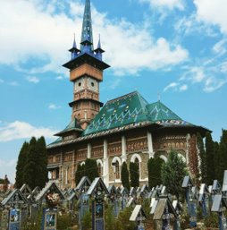  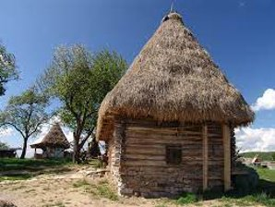 | It is common knowledge that Romania's rich culture and traditions thrive in the country side. Some such towns serving as an escape from urban life and an emersion into the routines of our ancestors. Frequent sights being that of animals such as cows and sheep roaming virtually unbothered through the adjacent hills and meadows, or that of villagers tending their vegetable gardens or ploughing the fields. Naturally these places are a target for people especially foreigners to experience authentic Romanian customs and understand our national background. Although, this type of tourism has only seen a rise in popularity in recent years, we can expect it to reach its way to the top, due to the picturesque settings it offers and the characteristic hospitability of the hosts, who more often than not end up treating the visitors as family.​  Of the towns that have become hubs for heritage tourism are included:​  -Runcuri is a definite must see when it comes to authenticity. Situated in the county of Bihor the village has only a couple of houses, almost entirely made up of traditional homes and all their straw roof glory. Most of these are rentals and decorated accordingly, here your host will also indulge you with local cuisine and show you around the habits of those in generations past.​  -Săpânța perhaps the most famous on the list, has become well known for its peculiar cemetery and it's even more peculiar gravestones consisting of brightly color wood depicting a comic personalized to the deceased. This tradition, while a bit shocking provides insight into our native, sometimes dark, sense of humor.​

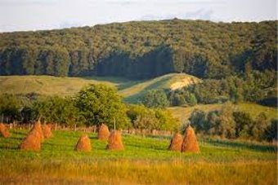  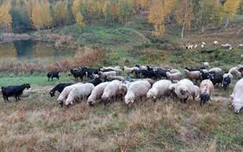 | While there remain a number of wealthy and flowering towns that our country is and should be proud of, the truth of the matter is that many are also riddled with poverty due to a lack of both youth and funds from the town hall. But what can we do to help preserve and consolidate these places that are such an integral part of our heritage There are two angles from which to examine this dilemma:  The people living in rural live in harmony with their landscape and honor it to the best of their ability. This mentality likely stemming from the fact that not so long ago the crops and animals around them directly affected their livelihood and for some it still does. All this to say that without knowing the word for it most maintain an environmentalist view to the world. To ensure this attitude is preserved some schools have taken action and are now organizing cleanups as well as nature walks to encourage children to hone their love of the earth.​  The state and especially the city hall can take action against the decrease in population or the loss of traditions. These approaches are often too costly for villages with already low income, but through the help of European funds, measures can be taken. Some such measures include: giving out more money to new parents to discourage young couples from leaving to start families elsewhere, investing in after school programs to teach kids about tradition and the environment, the hiring of people to help regrow the flora and fauna of the area and the list goes on.​  Finally, it is plain to see that actions can and should be taken by both individuals and the government to guarantee the preserving of both customs and landscape.​

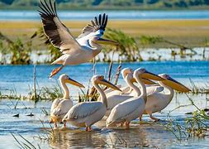  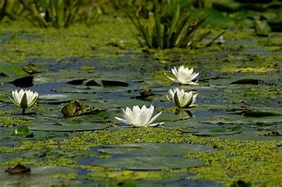 | The mighty Danube River flows 1,788 miles from its springs in Germany's Black Forest to the Black Sea. Just before reaching the sea it forms the second largest and best preserved of Europe's deltas, making it any wildlife enthusiast’s paradise.  Travelers can spend several days exploring its passages, teaming with the highest concentration of bird colonies in all of Europe. Millions of Egyptian white pelicans arrive here every spring to raise their young, while equal numbers of Arctic geese come here to escape the harsh winters of Northern Europe.  Bird watching season lasts from early spring to late summer. Birds are not the only inhabitants of the Delta. But did you know that there is also a rich community of fish and animals; from wildcats, foxes and wolves, to even an occasional boar or deer? Well, altogether, 3,450 animal species can be seen here, as well as 1,700 plant species.  The Delta is formed around the three main channels of the Danube, named after their respective ports: Chilia, in the north, Sulina in the middle, and Sfantu Gheorghe, also known as Saint George, in the south.  FUN FACT:  Did you know that the Danube River is the most international river on the planet? I’m not kidding! Its course runs across or forms a part of the borders of several countries such as Germany, Austria, Slovakia, Hungary, Croatia, Serbia, Romania, Bulgaria, Ukraine, and four capitals: Vienna, Bratislava, Budapest and Belgrade.

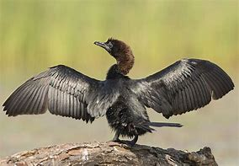  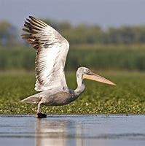  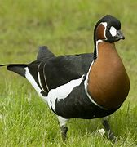 | While the traditional inhabitants are well integrated into this fragile ecosystem, tourists sometimes are not.  The Danube Delta has survived several ill-advised projects. During the communist period, Romania's dictator Nicolae Ceaușescu, although he was a hunter and fisherman himself, thought the Delta was "too wild" and needed to be tamed. His regime drained swamps, marshes and lakes and transformed the areas into agricultural fields. The government forced traditional fishermen to become farmers. It proved disastrous for the people and for the environment.  However, it is said that Mother Nature always fights back, and so the Delta had bounced back and after communism fell, the drained areas were re-flooded and have begun coming back to life.  The Danube Delta is one of our natural treasures where people can lose themselves in its pure majestic beauty. We can protect its precious future by enforcing laws that protect and sustain the ecosystem there.
"This project has been funded with support from the European Commission. This publication reflects the views only of the author, and the Commission cannot be held responsible for any use which may be made of the information contained therein."

