The BARCELOS ROOSTER
If you don’t have the book, you can use the PPT presentation prepared by the students:
C:\Users\Professor\OneDrive - Agrupamento de Escolas de Rio Tinto\Documentos\ERASMUS 2020-2022\UN-ID\MOBILITIES\C5 TURKEY\LESSON PLAN\Galo de Barcelos.pptm
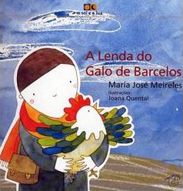
- Look at the book cover and answer the following questions:
Author
Designer
Title
Editor

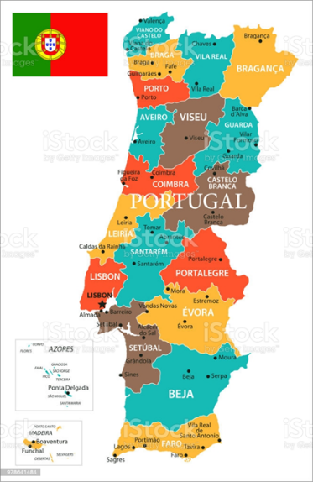
- Identify the city of Barcelos in the Europe, Iberian Peninsula and Portugal:
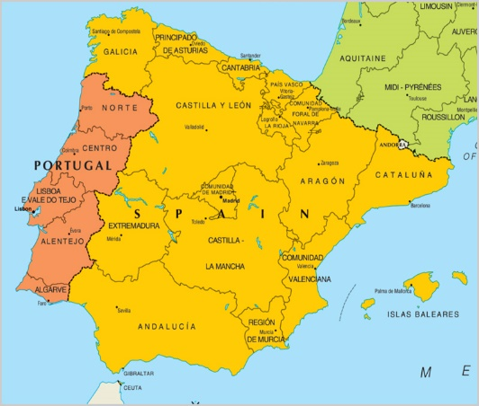
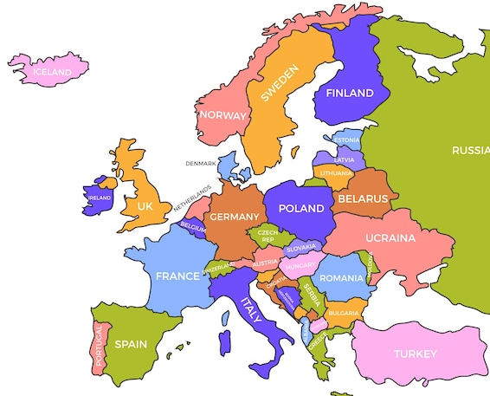

- Explain the meaning of the following words in the story, in your own words. If you don’t know, look them up online in Oxford Learner’s Dictionary:
Legend
Pilgrimage
Vow
Gallows
Mockery
To crow
Banquet
Judgement

- Identify the characters in the story and characterize them:
Pilgrim
Judge
Rooster
Executioner

- What is “Camiño de Santiago”? Do you have a similar tradition in your country? Please relate to it.
_______________________________________________________________________
_______________________________________________________________________
- After a brief discussion with your peers, write down what you believe is the Moral of the Story.
_______________________________________________________________________
_______________________________________________________________________
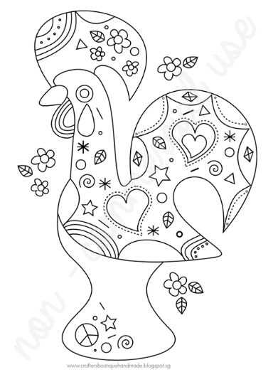
- Please decorate the template with the representation of the colours and values that the Portuguese people attribute to the rooster. (you should hand out the students a blank template so that they can use their imagination. If you have special needs children, use this one)

- As a final activity, keeping in mind that it was the end of the story that dictated the Rooster would become a symbol of the country, and therefore, a different end to the story could have originated a different tradition or moral, each student is going to rewrite the end of this legend from the given sentence:
“And the day came for the Pilgrim to be hung…”
_______________________________________________________________________
_______________________________________________________________________
_______________________________________________________________________
_______________________________________________________________________
_______________________________________________________________________
_______________________________________________________________________
_______________________________________________________________________
_______________________________________________________________________
_______________________________________________________________________
_______________________________________________________________________
_______________________________________________________________________

